SAP Business Technology Platform (Part-1)

Presented To
Pro. Jürgen Weiner

By Team - C
Abdul Shukoor
Palash Wani
Tharani Natrajan

Use Case 3: Sales

- Entity-Relation Diagram
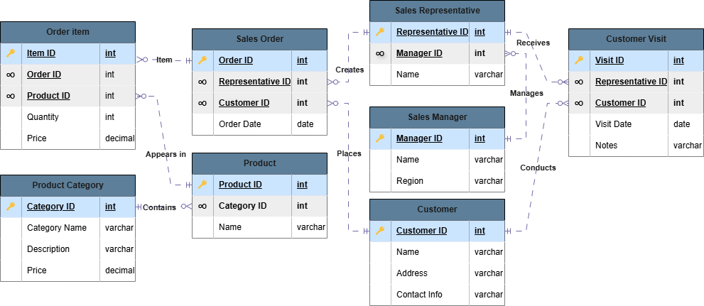

- Create Roles
CREATE ROLE SALES_ADMIN;
CREATE ROLE SALES_MANAGER;
CREATE ROLE SALES_REPRESENTATIVE;
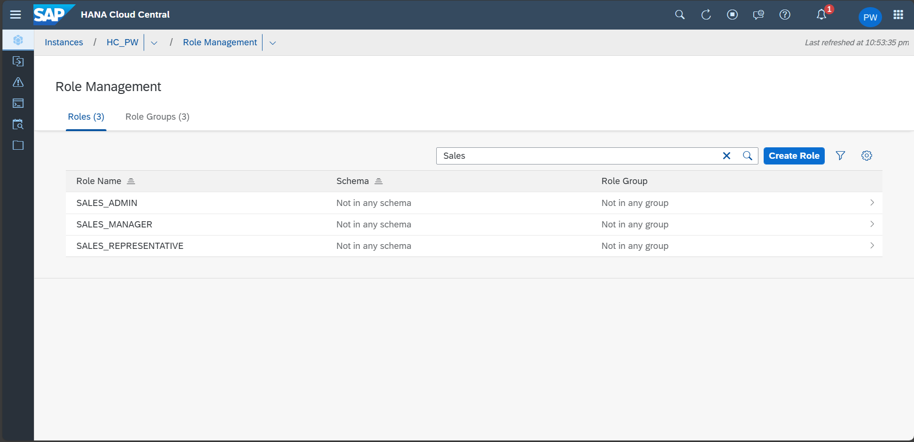

- Create User Group
CREATE USERGROUP SALES_USER_GROUP
SET PARAMETER 'minimal_password_length' = '8', 'force_first_password_change' = 'FALSE';
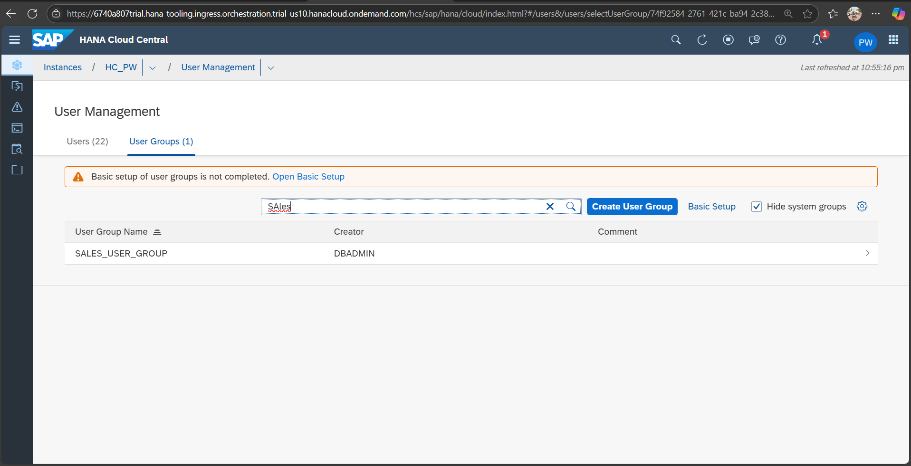

- Create User
CREATE USER SALE_ADMIN PASSWORD Password1 no force_first_password_change SET USERGROUP SALES_USER_GROUP;
CREATE USER SALES_MANAGER_1 PASSWORD Password1 no force_first_password_change SET USERGROUP SALES_USER_GROUP;
CREATE USER UNI_REPRENTATIVE_1 PASSWORD Password1 no force_first_password_change SET USERGROUP SALES_USER_GROUP;
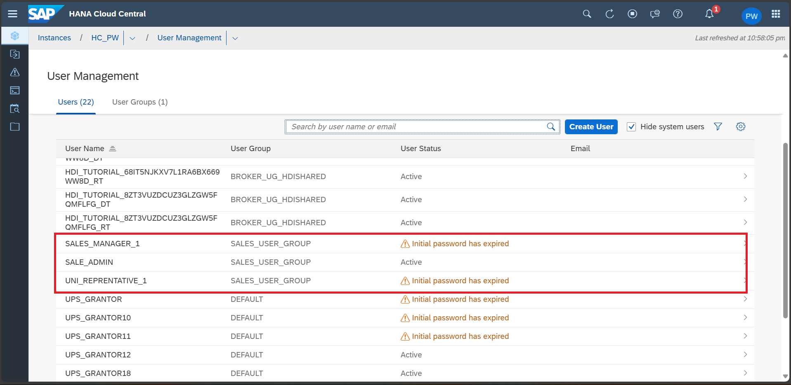

- Grant
-- Role-specific
GRANT TRUST ADMIN TO SALES_ADMIN; -- required to create a PSE
GRANT CERTIFICATE ADMIN TO SALES_ADMIN; --required to create a certificate
GRANT CREDENTIAL ADMIN TO SALES_ADMIN --required to create a credential
GRANT EXPORT TO SALES_ADMIN; --required to enable export of data
GRANT IMPORT TO SALES_ADMIN; --required to enable import of data GRANT CREATE REMOTE SOURCE TO SALES_ADMIN; --allow setting the PSE purpose to REMOTE SOURCE and to create REMOTE SOURCES
GRANT RESOURCE ADMIN TO SALES_ADMIN; --allow viewing of diagnostic files
GRANT CATALOG READ TO SALES_ADMIN; --allow access to system views
GRANT INIFILE ADMIN TO SALES_ADMIN; --allow altering of system settings
-- User-specific
GRANT CREATE SCHEMA TO SALE_ADMIN;
GRANT SALES_ADMIN TO SALE_ADMIN;
GRANT SALES_MANAGER TO SALES_MANAGER_1;
GRANT SALES_REPRESENTATIVE TO UNI_REPRENTATIVE_1;
-- Create Schema and corresponding rights
CONNECT SALE_ADMIN PASSWORD Password1;
CREATE SCHEMA SALES;
GRANT ALL PRIVILEGES ON SCHEMA SALES TO SALES_ADMIN;
GRANT SELECT ON SCHEMA SALES TO SALES_MANAGER;

- Create Table
Create Table
CONNECT SALE_ADMIN PASSWORD Password1;
SET SCHEMA SALES;

-- Sales Manager Table
CREATE TABLE SalesManager (
ManagerID INT PRIMARY KEY,
Name VARCHAR(100) NOT NULL,
Region VARCHAR(50) NOT NULL
);

-- Sales Representative Table
CREATE TABLE SalesRepresentative (
RepresentativeID INT PRIMARY KEY,
ManagerID INT NOT NULL,
Name VARCHAR(100) NOT NULL,
FOREIGN KEY (ManagerID) REFERENCES SalesManager(ManagerID)
);

-- Customer Table (with INT ContactInfo as requested)
CREATE TABLE Customer (
CustomerID INT PRIMARY KEY,
Name VARCHAR(100) NOT NULL,
Address VARCHAR(200) NOT NULL,
ContactInfo INT NOT NULL
);

-- Product Category Table
CREATE TABLE ProductCategory (
CategoryID INT PRIMARY KEY,
CategoryName VARCHAR(100) NOT NULL,
Description VARCHAR(255)
);

-- Product Table
CREATE TABLE Product (
ProductID INT PRIMARY KEY,
CategoryID INT NOT NULL,
Name VARCHAR(100) NOT NULL,
FOREIGN KEY (CategoryID) REFERENCES ProductCategory(CategoryID)
);

-- Order Table
CREATE TABLE SalesOrder (
OrderID INT PRIMARY KEY,
RepresentativeID INT NOT NULL,
CustomerID INT NOT NULL,
OrderDate DATE NOT NULL,
FOREIGN KEY (RepresentativeID) REFERENCES SalesRepresentative(RepresentativeID),
FOREIGN KEY (CustomerID) REFERENCES Customer(CustomerID)
);

-- Order Item Table
CREATE TABLE OrderItem (
ItemID INT PRIMARY KEY,
OrderID INT NOT NULL,
ProductID INT NOT NULL,
Quantity INT NOT NULL,
Price DECIMAL(10,2) NOT NULL,
FOREIGN KEY (OrderID) REFERENCES SalesOrder(OrderID),
FOREIGN KEY (ProductID) REFERENCES Product(ProductID)
);

-- Customer Visit Table
CREATE TABLE CustomerVisit (
VisitID INT PRIMARY KEY,
RepresentativeID INT NOT NULL,
CustomerID INT NOT NULL,
VisitDate DATE NOT NULL,
Notes VARCHAR(500),
FOREIGN KEY (RepresentativeID) REFERENCES SalesRepresentative(RepresentativeID),
FOREIGN KEY (CustomerID) REFERENCES Customer(CustomerID)
);

- Populate Data
-- Insert sample data into SalesManager
INSERT INTO SalesManager VALUES (1, 'Robert Johnson', 'Northeast');
INSERT INTO SalesManager VALUES (2, 'Sarah Williams', 'Midwest');
INSERT INTO SalesManager VALUES (3, 'Michael Chen', 'West Coast');
INSERT INTO SalesManager VALUES (4, 'Laura Simmons', 'Southeast');
INSERT INTO SalesManager VALUES (5, 'Carlos Mendoza', 'Southwest');
INSERT INTO SalesManager VALUES (6, 'Anita Kapoor', 'Northwest');
INSERT INTO SalesManager VALUES (7, 'Thomas Becker', 'Central Europe');
INSERT INTO SalesManager VALUES (8, 'Yuki Tanaka', 'Asia-Pacific');
INSERT INTO SalesManager VALUES (9, 'Fatima Al-Fayed', 'Middle East & Africa');
INSERT INTO SalesManager VALUES (10, 'Lucas Martins', 'South America');

-- Insert sample data into SalesRepresentative
INSERT INTO SalesRepresentative VALUES (101, 1, 'Emily Davis');
INSERT INTO SalesRepresentative VALUES (102, 1, 'David Wilson');
INSERT INTO SalesRepresentative VALUES (103, 2, 'Jennifer Brown');
INSERT INTO SalesRepresentative VALUES (104, 3, 'James Miller');
INSERT INTO SalesRepresentative VALUES (105, 4, 'Nathan Lee');
INSERT INTO SalesRepresentative VALUES (106, 4, 'Alicia Gomez');
INSERT INTO SalesRepresentative VALUES (107, 5, 'Raj Patel');
INSERT INTO SalesRepresentative VALUES (108, 5, 'Sophia Martinez');
INSERT INTO SalesRepresentative VALUES (109, 6, 'Ethan Wright');
INSERT INTO SalesRepresentative VALUES (110, 6, 'Mia Johansson');
INSERT INTO SalesRepresentative VALUES (111, 7, 'Felix Schneider');
INSERT INTO SalesRepresentative VALUES (112, 7, 'Hanna Müller');
INSERT INTO SalesRepresentative VALUES (113, 8, 'Kenji Sato');
INSERT INTO SalesRepresentative VALUES (114, 8, 'Mei Lin');
INSERT INTO SalesRepresentative VALUES (115, 9, 'Omar Hassan');
INSERT INTO SalesRepresentative VALUES (116, 9, 'Layla Mansour');
INSERT INTO SalesRepresentative VALUES (117, 10, 'Bruno Silva');
INSERT INTO SalesRepresentative VALUES (118, 10, 'Camila Torres');

-- Insert sample data into Customer
INSERT INTO Customer VALUES (c, 'Tech Solutions Inc.', '123 Business Ave, Boston, MA', 6175551001);
INSERT INTO Customer VALUES (1002, 'Global Enterprises', '456 Corporate Blvd, Chicago, IL', 3125552002);
INSERT INTO Customer VALUES (1003, 'Innovative Systems', '789 Tech Park, San Francisco, CA', 4155553003);
INSERT INTO Customer VALUES (1004, 'Data Analytics Co.', '321 Digital Lane, New York, NY', 2125554004);
INSERT INTO Customer VALUES (1005, 'NextGen Robotics Ltd.', '987 Innovation Drive, Austin, TX', 5125555005);
INSERT INTO Customer VALUES (1006, 'Quantum Tech Labs', '654 Quantum Blvd, Seattle, WA', 2065556006);
INSERT INTO Customer VALUES (1007, 'Bright Future Education', '321 Learning Way, Denver, CO', 3035557007);
INSERT INTO Customer VALUES (1008, 'Green Energy Corp.', '159 Eco Street, Portland, OR', 5035558008);
INSERT INTO Customer VALUES (1009, 'Skyline Architecture Group', '222 Skyline Ave, Atlanta, GA', 4045559009);
INSERT INTO Customer VALUES (1010, 'Fusion Medical Systems', '110 Health Park, Raleigh, NC', 9195551010);
INSERT INTO Customer VALUES (1011, 'Visionary Marketing LLC', '443 Campaign Blvd, Miami, FL', 3055551111);
INSERT INTO Customer VALUES (1012, 'SecureNet Solutions', '876 Firewall Lane, Dallas, TX', 2145551212);
INSERT INTO Customer VALUES (1013, 'Urban Mobility Inc.', '132 Transit Road, Chicago, IL', 3125551313);
INSERT INTO Customer VALUES (1014, 'NeoSpace Innovations', '789 Orbit Drive, Los Angeles, CA', 2135551414);

-- Insert sample data into ProductCategory
INSERT INTO ProductCategory VALUES (10, 'Software', 'Business applications and tools');
INSERT INTO ProductCategory VALUES (20, 'Hardware', 'Computer equipment and devices');
INSERT INTO ProductCategory VALUES (30, 'Services', 'Consulting and support services');
INSERT INTO ProductCategory VALUES (40, 'Networking', 'Routers, switches, and network hardware');
INSERT INTO ProductCategory VALUES (50, 'Cloud Services', 'Hosted solutions and storage');
INSERT INTO ProductCategory VALUES (60, 'Mobile Devices', 'Smartphones, tablets, and accessories');
INSERT INTO ProductCategory VALUES (70, 'Security', 'Cybersecurity software and tools');
INSERT INTO ProductCategory VALUES (80, 'AI Solutions', 'Artificial Intelligence and machine learning tools');
INSERT INTO ProductCategory VALUES (90, 'IoT Devices', 'Internet of Things hardware and controllers');
INSERT INTO ProductCategory VALUES (100, 'Training & Certification', 'Employee training programs and certification services');
INSERT INTO ProductCategory VALUES (110, 'Energy Solutions', 'Smart energy management and power backup systems');
INSERT INTO ProductCategory VALUES (120, 'E-commerce Tools', 'Platforms and plugins for online stores');
INSERT INTO ProductCategory VALUES (130, 'Collaboration Tools', 'Project management and communication platforms');

-- Insert sample data into Product
INSERT INTO Product VALUES (5001, 10, 'Enterprise CRM Suite', 4999.99);
INSERT INTO Product VALUES (5002, 10, 'Data Analytics Pro', 3499.99);
INSERT INTO Product VALUES (5003, 20, 'Business Server X9', 8999.99);
INSERT INTO Product VALUES (5004, 20, 'Workstation Pro', 2499.99);
INSERT INTO Product VALUES (5005, 30, 'Premium Support Package', 1999.99);
INSERT INTO Product VALUES (5006, 40, 'Enterprise Router 500', 1299.99);
INSERT INTO Product VALUES (5007, 40, 'Smart Switch 24-Port', 899.99);
INSERT INTO Product VALUES (5008, 50, 'Cloud Storage 1TB Plan', 999.99);
INSERT INTO Product VALUES (5009, 50, 'Hosted Email Service', 799.99);
INSERT INTO Product VALUES (5010, 60, 'ProTab 12X Tablet', 749.99);
INSERT INTO Product VALUES (5011, 60, 'Smartphone XZ Max', 999.99);
INSERT INTO Product VALUES (5012, 70, 'CyberShield Antivirus Suite', 299.99);
INSERT INTO Product VALUES (5013, 70, 'SecureVPN Enterprise', 199.99);
INSERT INTO Product VALUES (5014, 80, 'AI Forecasting Engine', 5999.99);
INSERT INTO Product VALUES (5015, 80, 'Vision Recognition SDK', 4299.99);
INSERT INTO Product VALUES (5016, 90, 'Smart Sensor Hub', 899.99);
INSERT INTO Product VALUES (5017, 90, 'IoT Gateway Pro', 1199.99);
INSERT INTO Product VALUES (5018, 100, 'Employee Skills Training Pack', 499.99);
INSERT INTO Product VALUES (5019, 100, 'Cloud Certification Course', 799.99);
INSERT INTO Product VALUES (5020, 110, 'Smart UPS 2000VA', 1499.99);
INSERT INTO Product VALUES (5021, 110, 'EnergyMonitor Pro', 1299.99);
INSERT INTO Product VALUES (5022, 120, 'E-Store Builder', 999.99);
INSERT INTO Product VALUES (5023, 120, 'Payment Gateway Plugin', 299.99);
INSERT INTO Product VALUES (5024, 130, 'TeamCollab Suite', 699.99);
INSERT INTO Product VALUES (5025, 130, 'Agile Project Manager Pro', 899.99);
INSERT INTO Product VALUES (5026, 40, 'NextGen Firewall Appliance', 1599.99);
INSERT INTO Product VALUES (5027, 40, 'CloudEdge Router X1', 1099.99);
INSERT INTO Product VALUES (5028, 50, 'Virtual Machine Hosting - Pro Plan', 1299.99);
INSERT INTO Product VALUES (5029, 50, 'Cloud Backup Unlimited', 899.99);
INSERT INTO Product VALUES (5030, 60, 'Business Tablet M10', 699.99);
INSERT INTO Product VALUES (5031, 60, 'Executive Smartphone Z Ultra', 1099.99);
INSERT INTO Product VALUES (5032, 70, 'Email Protection Suite', 399.99);
INSERT INTO Product VALUES (5033, 70, 'Enterprise Firewall Software', 599.99);
INSERT INTO Product VALUES (5034, 80, 'Smart Recommendation Engine', 4999.99);
INSERT INTO Product VALUES (5035, 80, 'Predictive Maintenance Module', 4599.99);
INSERT INTO Product VALUES (5036, 90, 'IoT Motion Detector Kit', 649.99);
INSERT INTO Product VALUES (5037, 90, 'Industrial IoT Controller', 1499.99);
INSERT INTO Product VALUES (5038, 100, 'Leadership Development Course', 599.99);
INSERT INTO Product VALUES (5039, 100, 'Tech Onboarding Program', 399.99);
INSERT INTO Product VALUES (5040, 110, 'Solar Battery Storage Unit', 2999.99);
INSERT INTO Product VALUES (5041, 110, 'Smart Energy Controller', 999.99);
INSERT INTO Product VALUES (5042, 120, 'SEO Optimization Plugin', 199.99);
INSERT INTO Product VALUES (5043, 120, 'Abandoned Cart Recovery Tool', 249.99);
INSERT INTO Product VALUES (5044, 130, 'Remote Meeting Suite', 499.99);
INSERT INTO Product VALUES (5045, 130, 'Workflow Automation Tool', 799.99);

-- Insert sample data into SalesOrder
INSERT INTO SalesOrder VALUES (9001, 101, 1001, '2023-06-15');
INSERT INTO SalesOrder VALUES (9002, 102, 1002, '2023-06-18');
INSERT INTO SalesOrder VALUES (9003, 103, 1003, '2023-06-20');
INSERT INTO SalesOrder VALUES (9004, 104, 1004, '2023-06-22');
INSERT INTO SalesOrder VALUES (9005, 101, 1002, '2023-06-25');
INSERT INTO SalesOrder VALUES (9006, 105, 1005, '2023-07-03');
INSERT INTO SalesOrder VALUES (9007, 106, 1006, '2023-07-05');
INSERT INTO SalesOrder VALUES (9008, 107, 1007, '2023-07-07');
INSERT INTO SalesOrder VALUES (9009, 108, 1008, '2023-07-09');
INSERT INTO SalesOrder VALUES (9010, 109, 1009, '2023-07-11');
INSERT INTO SalesOrder VALUES (9011, 110, 1010, '2023-07-13');
INSERT INTO SalesOrder VALUES (9012, 111, 1011, '2023-07-15');
INSERT INTO SalesOrder VALUES (9013, 112, 1012, '2023-07-17');
INSERT INTO SalesOrder VALUES (9014, 113, 1013, '2023-07-19');
INSERT INTO SalesOrder VALUES (9015, 114, 1014, '2023-07-21');
INSERT INTO SalesOrder VALUES (9016, 115, 1001, '2023-07-23');
INSERT INTO SalesOrder VALUES (9017, 116, 1002, '2023-07-25');
INSERT INTO SalesOrder VALUES (9018, 117, 1003, '2023-07-27');
INSERT INTO SalesOrder VALUES (9019, 118, 1004, '2023-07-29');

-- Insert sample data into OrderItem
INSERT INTO OrderItem VALUES (8001, 9001, 5001, 1, 4999.99);
INSERT INTO OrderItem VALUES (8002, 9001, 5005, 1, 1999.99);
INSERT INTO OrderItem VALUES (8003, 9002, 5003, 2, 8999.99);
INSERT INTO OrderItem VALUES (8004, 9003, 5002, 1, 3499.99);
INSERT INTO OrderItem VALUES (8005, 9004, 5004, 5, 2499.99);
INSERT INTO OrderItem VALUES (8006, 9005, 5001, 1, 4999.99);
INSERT INTO OrderItem VALUES (8007, 9005, 5002, 1, 3499.99);
INSERT INTO OrderItem VALUES (8008, 9006, 5026, 1, 1599.99);
INSERT INTO OrderItem VALUES (8009, 9006, 5030, 2, 699.99);
INSERT INTO OrderItem VALUES (8010, 9007, 5028, 1, 1299.99);
INSERT INTO OrderItem VALUES (8011, 9008, 5032, 3, 399.99);
INSERT INTO OrderItem VALUES (8012, 9009, 5040, 1, 2999.99);
INSERT INTO OrderItem VALUES (8013, 9010, 5037, 4, 1499.99);
INSERT INTO OrderItem VALUES (8014, 9011, 5022, 1, 999.99);
INSERT INTO OrderItem VALUES (8015, 9012, 5014, 1, 5999.99);
INSERT INTO OrderItem VALUES (8016, 9013, 5044, 5, 499.99);
INSERT INTO OrderItem VALUES (8017, 9014, 5010, 2, 749.99);
INSERT INTO OrderItem VALUES (8018, 9015, 5034, 1, 4999.99);
INSERT INTO OrderItem VALUES (8019, 9016, 5007, 3, 899.99);
INSERT INTO OrderItem VALUES (8020, 9017, 5020, 1, 1499.99);
INSERT INTO OrderItem VALUES (8021, 9018, 5012, 2, 299.99);
INSERT INTO OrderItem VALUES (8022, 9019, 5023, 1, 249.99);

-- Insert sample data into CustomerVisit
INSERT INTO CustomerVisit VALUES (7001, 101, 1001, '2023-06-10', 'Initial product demonstration');
INSERT INTO CustomerVisit VALUES (7002, 102, 1002, '2023-06-12', 'Contract renewal discussion');
INSERT INTO CustomerVisit VALUES (7003, 103, 1003, '2023-06-14', 'New feature presentation');
INSERT INTO CustomerVisit VALUES (7004, 104, 1004, '2023-06-19', 'Installation follow-up');
INSERT INTO CustomerVisit VALUES (7005, 101, 1002, '2023-06-24', 'Upsell opportunity identified');
INSERT INTO CustomerVisit VALUES (7006, 101, 1005, '2023-07-01', 'Product demo and feasibility discussion');
INSERT INTO CustomerVisit VALUES (7007, 102, 1006, '2023-07-02', 'Security needs assessment');
INSERT INTO CustomerVisit VALUES (7008, 103, 1007, '2023-07-04', 'Training program proposal');
INSERT INTO CustomerVisit VALUES (7009, 104, 1008, '2023-07-05', 'Energy solution introduction');
INSERT INTO CustomerVisit VALUES (7010, 101, 1009, '2023-07-06', 'System upgrade consultation');
INSERT INTO CustomerVisit VALUES (7011, 102, 1010, '2023-07-07', 'Healthcare compliance briefing');
INSERT INTO CustomerVisit VALUES (7012, 103, 1011, '2023-07-08', 'Marketing platform integration');
INSERT INTO CustomerVisit VALUES (7013, 104, 1012, '2023-07-09', 'Firewall and endpoint security demo');
INSERT INTO CustomerVisit VALUES (7014, 101, 1013, '2023-07-10', 'Smart mobility and IoT applications');
INSERT INTO CustomerVisit VALUES (7015, 102, 1014, '2023-07-11', 'AI-based analytics workshop');

- Alter Table
ALTER TABLE Product ADD (Price DECIMAL(10,2) DEFAULT 0 NOT NULL);

- Create View

  - CATEGORY_PRODUCT_VIEW
CREATE OR REPLACE VIEW CATEGORY_PRODUCT_VIEW AS
SELECT
P.ProductID,
P.Name AS Product_Name,
C.CategoryID,
C.CategoryName,
C.Description AS Category_Description
FROM Product P
LEFT JOIN SALES.ProductCategory C ON P.CategoryID = P.CategoryID

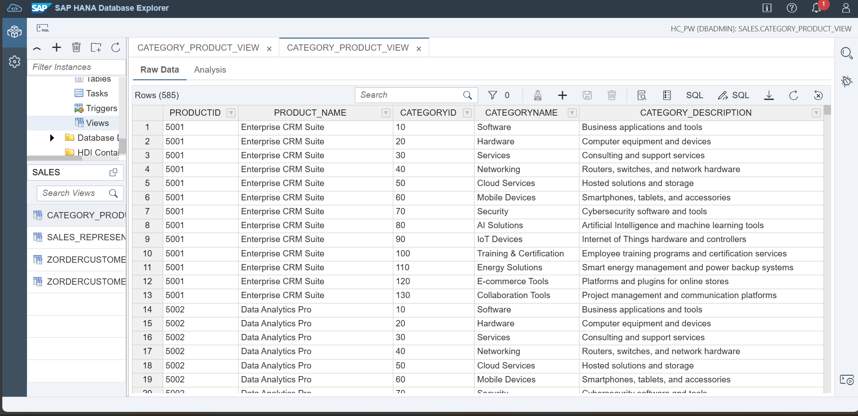

  - SALES_REPRESENTATIVE_VIEW

CREATE OR REPLACE VIEW SALES_REPRESENTATIVE_VIEW AS
SELECT
SR.REPRESENTATIVEID,
SR.Name,
COUNT(SO.OrderID) AS Total_Orders
FROM
SalesRepresentative SR
LEFT JOIN
SalesOrder SO ON SO.RepresentativeID = SR.RepresentativeID
GROUP BY
SR.RepresentativeID, SR.Name

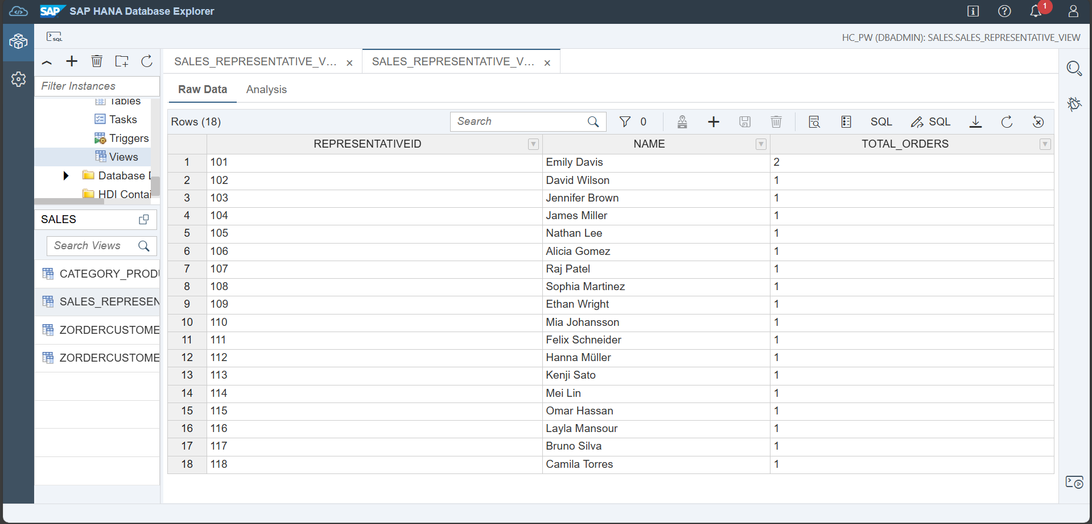

- Create Function

  - AVERAGE_SALES_PER_CUSTOMER
CREATE OR REPLACE FUNCTION AVERAGE_SALES_PER_CUSTOMER(IN CustomerID INT)
RETURNS avg_sales NUMERIC(10, 2)
AS
BEGIN
DECLARE EXIT HANDLER FOR SQLEXCEPTION avg_sales := '-1';
SELECT TO_DECIMAL(ROUND(SUM(OI.Price * OI.Quantity)/COUNT(DISTINCT SO.CustomerID), 2, ROUND_HALF_UP))
INTO avg_sales
FROM SalesOrder SO
JOIN OrderItem OI ON SO.ORDERID = OI.ORDERID;
END;

For Input Parameter: 1001
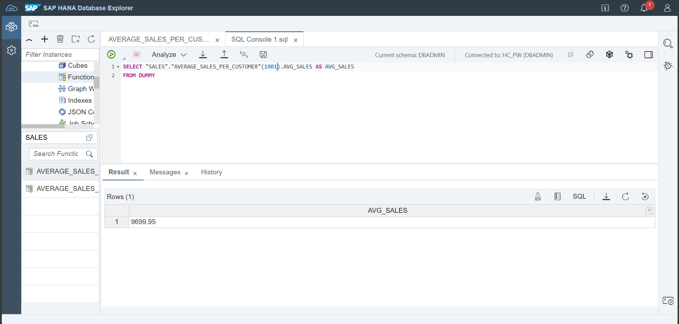

  - AVERAGE_SALES_PER_SALES_REPRESENTATIVE
CREATE OR REPLACE FUNCTION AVERAGE_SALES_PER_SALES_REPRESENTATIVE(IN REPRESENTATIVEID INT)
RETURNS avg_sales NUMERIC(10, 2)
AS
BEGIN
DECLARE EXIT HANDLER FOR SQLEXCEPTION avg_sales := '-1';
SELECT TO_DECIMAL(ROUND(SUM(OI.Price * OI.Quantity)/COUNT(DISTINCT SO.RepresentativeID), 2, ROUND_HALF_UP))
INTO avg_sales
FROM OrderItem OI
JOIN SalesOrder SO ON OI.ORDERID = SO.ORDERID
WHERE SO.REPRESENTATIVEID = :REPRESENTATIVEID;
END;
For Input Parameter: 101
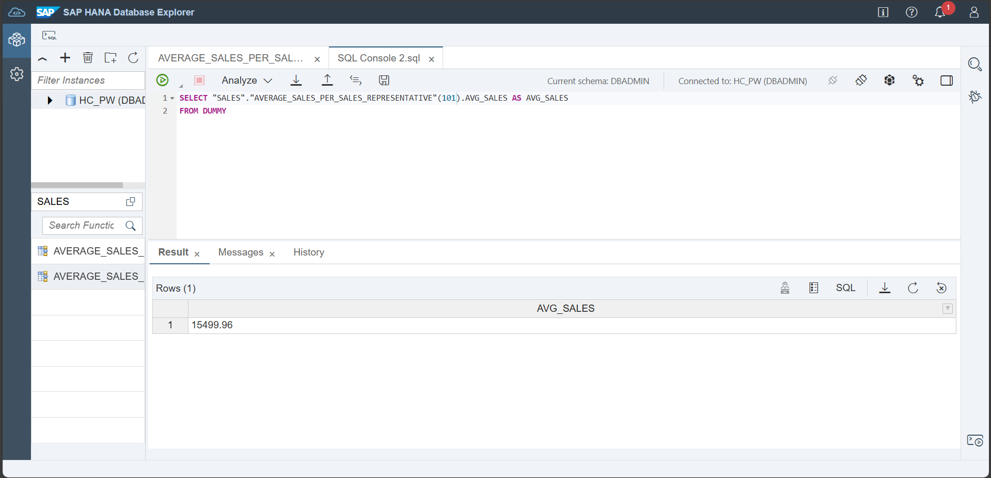

- Create Calculation View
  - CVIEW_TOP_5_CATEGORIES_SOLD
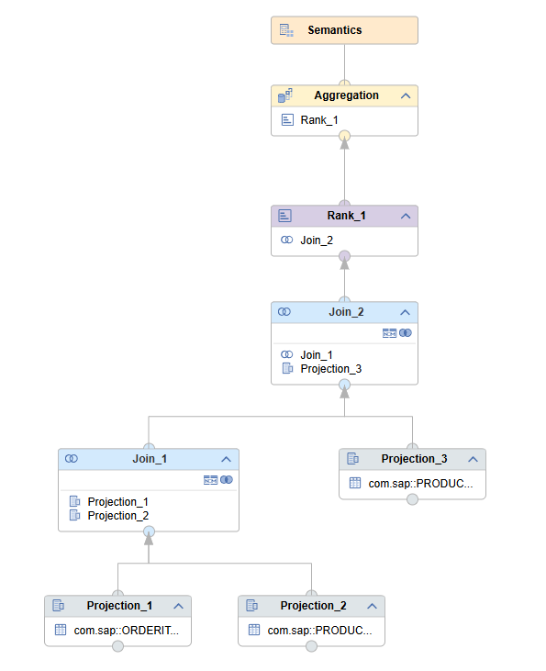
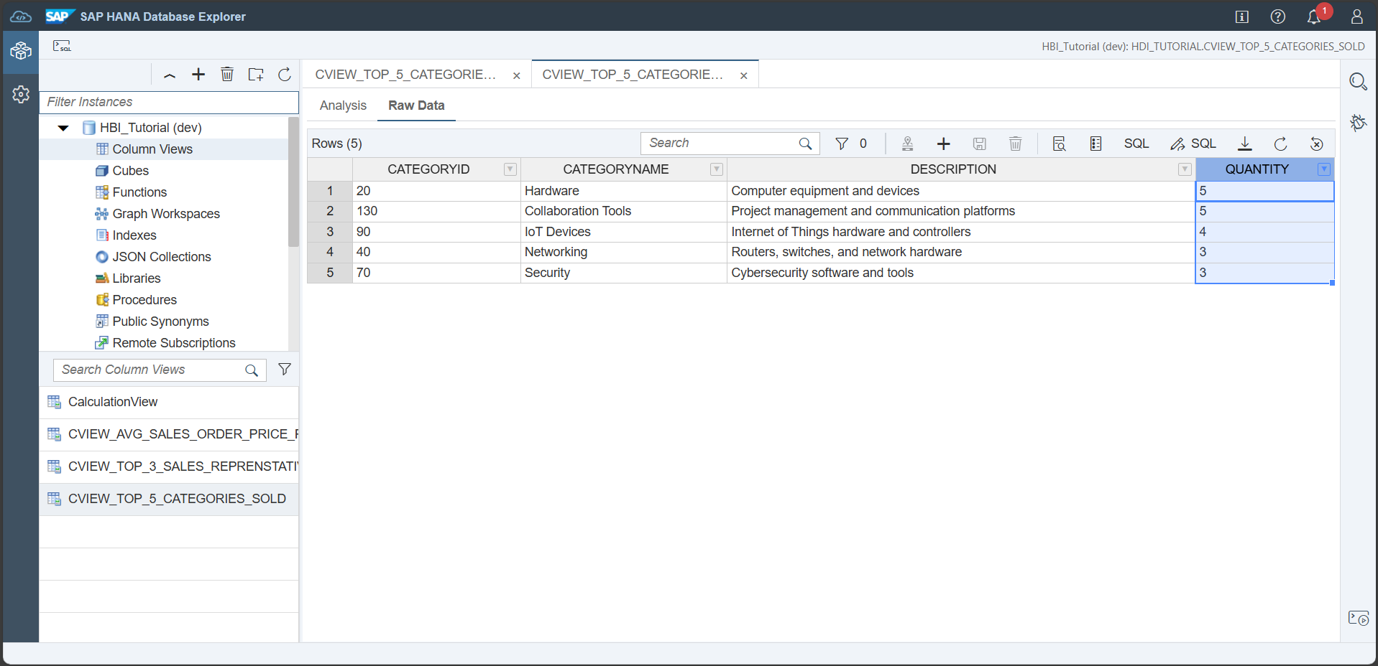

  - CVIEW_AVG_SALES_ORDER_PRICE_PER_CUSTOMER
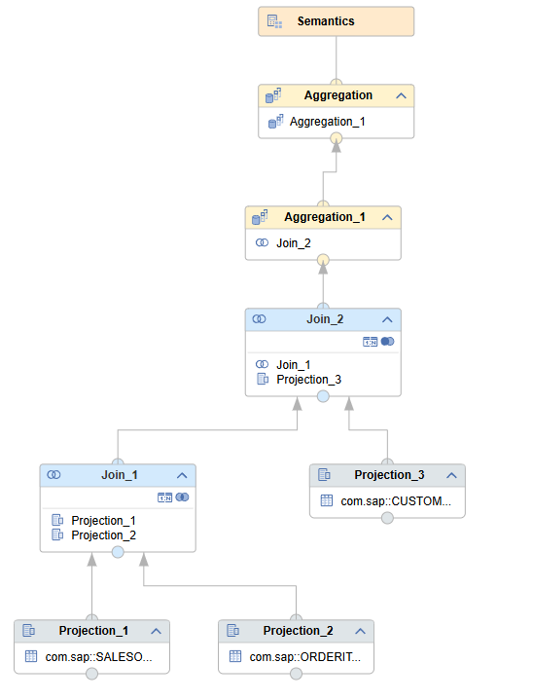

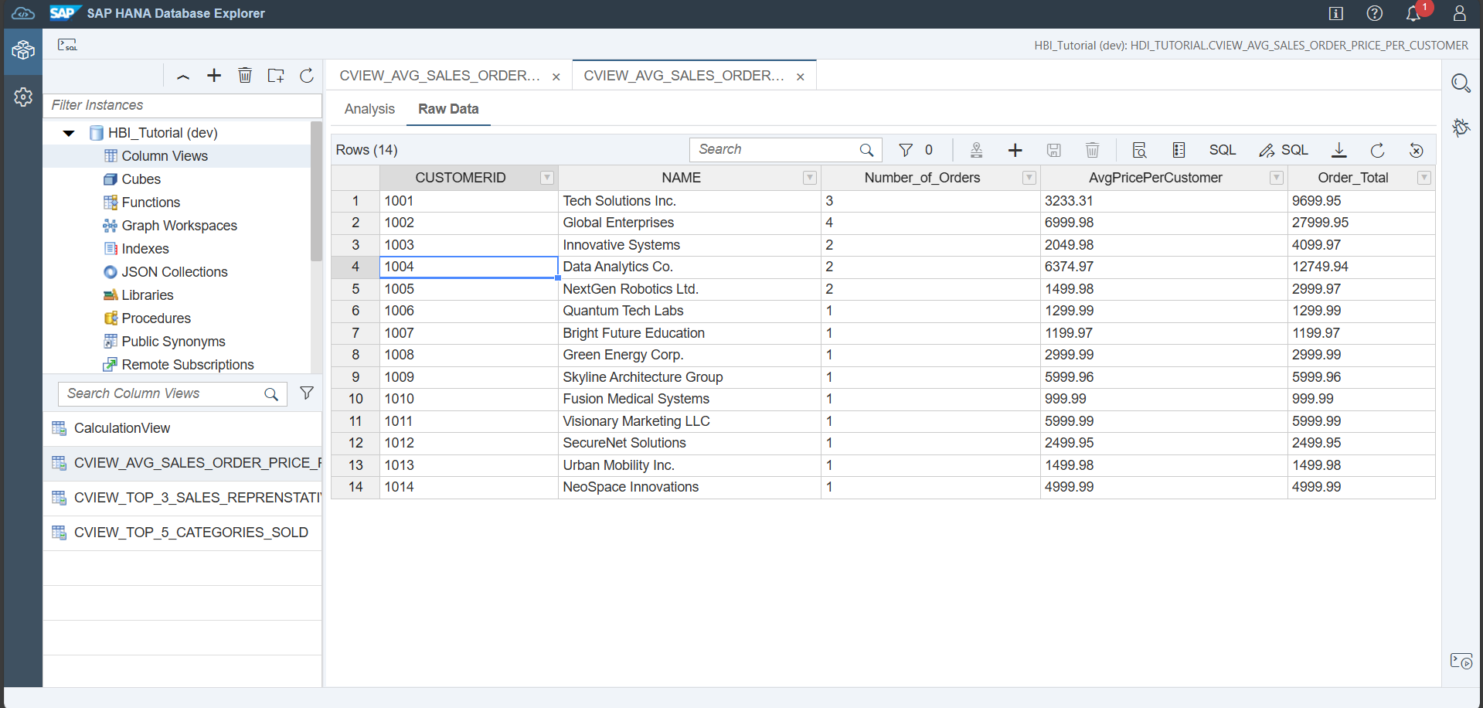

  - CVIEW_TOP_3_SALES_REPRENSTATIVES
